Mission: Fire Tracks

Level: Easy

Doc Brown wants to know how fast his DeLorean is given the distance and time. He wants to be able to enter the distance, in miles, and the time, in hours. The output should be the speed, in miles per hour. Help Doc Brown out by writing a program that will calculate the DeLorean’s speed.

**Some important information:**

Speed = Distance / Time

**Here is an example:**

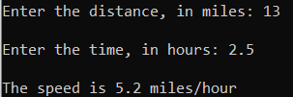

**What topics are covered:**

* Input / output
* Variables